**Device Storage Widget input type**

**Installation**

1. Copy **com.temenos.widgets.hybrid.deviceStorage** folder in your widgets folder (Ex: /{your project/templates })
2. Copy the content of **Insert in widget.xml** in your widget.xml file within your project
3. Make sure the **cordova_loader.js** file is inserted in your template header for the phase where you want to use the **Device Storage** widget.

Insert ***<script src="$$HTML_LOCATION$/js/cordova/cordova_loader.js"></script>*** in your header TPL.

**How to use**

1. You will have to insert a new question in the **Process Editor**
2. In the **Presentation Editor** -> **Double Click on the proper input** -> **Answer** -> **Control tab** -> **Display Type** -> Select the **Device Storage**  type
3. Within Widget Details tab you have to set up the widget settings.
4. Item Key field - item's key within the storage device associated with this question (The key with which are saved data (Question's answers) within Device Storage )
5. Storage Type . There are 2 kind of storage :
6. PERMANENT - the data are saved persistent in device memory .
7. TEMPORARY - works the same way in every respect, except that all data is cleared each time the app closes.

**How it’s works**

This has the same behavior as a normal question input, except the input value is taken from Device Storage by specific key in case this isn't set within Edge data store. If the input value is set within Edge data store and she is different than her Device Storage correspondent, when the page is loaded (on DeviceReady event ) the Device Storage will be updated automatically .

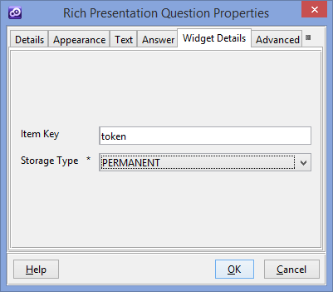

**Device Storage Widget button type**

**Installation**

For installation you have to follow same steps as at “Device Storage Widget input type” installation as described above .

**How to use**

1. You will have to add a new custom button in your presentation. Within **Appereance** -> **Button tab** for ”Display Type” field you have to select “Device Storage Button “
2. Within Widget Details tab you have to set up the widget settings.
3. Storage Type . There are 2 kind of storage :
4. PERMANENT - the data are saved persistent in device memory .
5. TEMPORARY - works the same way in every respect, except that all data is cleared each time the app closes.
6. Button Action - Which storage function is called when the button is pressed.
7. SET ITEM - Assigns a keyed item's value..
8. GET ITEM - Returns the item identified by the specified key.
9. REMOVE ITEM - Removes the item identified by the specified key.
10. CLEAR - Removes all of the key/value pairs.
11. Item Key field
12. Item Value field - This is applicable only for SET ITEM Action .
13. InputID field - ID of Input where to save storage value . This is applicable only for GET ITEM Action .
14. Auto click check box – Enable/Disable auto click button when page is loaded.

